SIMATS ENGINEERING (SAVEETHA SCHOOL OF ENGINEERING)
Department of Computer Science and Engineering
CO5 ASSESSMENT TOOL 2 – Seminar on Emerging Technologies

Course Code: | CSA1008 | Course Title: | Software Engineering
CO Assessed: | CO5 | Assessment: | Assessment Tool 2 – Seminar on Emerging Technologies
Weightage: | 20% | Total Marks: | 25
CO5 Statement: | Evaluate emerging technologies and societal impacts, maintaining and evolving software systems responsibly
Student Name: | ARTHI A | Reg. No.: | 192525152
Date: | 12.09.2026 | Duration: | 60 minutes

Code of Conduct
I ARTHI A(Name / Reg No) certify that this submission is my original work and that I have adhered to the guidelines specified for this assessment. I understand that any violation of academic integrity rules will result in disciplinary action.
Signature of the Student: _________________________
Annexure A – Seminar on Emerging Technologies
Instructions to Students:
Students must select the topic strictly according to the Serial Number (S.No.) order assigned to them.
S.No. | Seminar Topic
1 | Generative AI and Large Language Models (LLMs)
2 | AI Agents and Autonomous AI Systems
3 | Multimodal Artificial Intelligence
4 | Explainable and Trustworthy AI
5 | Edge AI and Intelligent Edge Computing
6 | Federated Learning and Privacy-Preserving AI
7 | Deep Learning for Computer Vision
8 | AI-Powered Medical Image Analysis
9 | Natural Language Processing with Transformer Models
10 | Retrieval-Augmented Generation (RAG)
11 | AI in Cybersecurity and Threat Detection
12 | Zero Trust Architecture and Modern Cybersecurity
13 | Post-Quantum Cryptography
14 | Quantum Computing and Quantum Algorithms
15 | Quantum Machine Learning
16 | Cloud-Native Computing and Microservices
17 | Serverless Computing and Function-as-a-Service
18 | Edge Computing and Fog Computing
19 | Cloud Security and Confidential Computing
20 | Digital Twins and Intelligent Simulation
21 | Internet of Things (IoT) and Smart Systems
22 | Industrial Internet of Things (IIoT)
23 | 5G/6G Networks and Next-Generation Communication
24 | Blockchain Technology and Decentralized Applications
25 | Web3 and Decentralized Internet
26 | Smart Contracts and Blockchain Applications
27 | Augmented Reality (AR) and Virtual Reality (VR)
28 | Extended Reality (XR) and Immersive Technologies
29 | Robotics and Autonomous Robots
30 | Human–Robot Interaction and Collaborative Robots
31 | Autonomous Vehicles and Intelligent Transportation Systems
32 | Smart Cities and AI-Driven Urban Technologies
33 | Metaverse Technologies and Virtual Worlds
34 | Brain–Computer Interfaces (BCI)
35 | Wearable Computing and Smart Wearable Devices
36 | Green Computing and Sustainable IT
37 | AI for Software Engineering and Code Generation
38 | DevSecOps and Intelligent CI/CD Pipelines
39 | Digital Forensics and AI-Based Cybercrime Investigation
40 | Privacy-Enhancing Technologies and Data Protection

Seminar Presentation Structure:
- Introduction to the Emerging Technology
- Need and Motivation
- Working Principle / Architecture
- Key Components and Technologies
- Applications / Real-World Use Cases
- Advantages and Limitations
- Recent Developments and Trends
- Challenges and Future Scope
- Case Study / Example
- Conclusion and References

Introduction to Distributed Computing

Introduction to the Emerging Technology
Distributed Computing is an emerging technology in which multiple independent computers, servers, or devices work together through a network to perform tasks and share resources. Instead of depending on a single powerful computer, distributed computing divides a large problem into smaller tasks and processes them across multiple machines.
The computers in a distributed system communicate with each other and coordinate their activities to achieve a common goal. This approach improves performance, scalability, resource utilization, reliability, and availability. Distributed computing forms the foundation of many modern technologies, including cloud computing, big-data processing, distributed databases, edge computing, and large-scale artificial intelligence systems.

1. Need and Motivation
The growth of digital applications has resulted in enormous amounts of data and increasingly complex computational requirements. A single computer may not have enough processing power, storage capacity, or network resources to handle such workloads efficiently.
The major motivations for distributed computing are:
- High performance: Large tasks can be divided among multiple computers and processed simultaneously.
- Scalability: Additional computers can be added when the workload increases.
- Resource sharing: Hardware, software, storage, and data can be shared among multiple systems.
- Reliability: If one machine fails, other machines can continue processing the workload.
- Cost efficiency: Multiple standard computers can sometimes provide greater computing capacity than one expensive high-end system.
- Large-scale data processing: Huge datasets can be distributed across multiple machines for faster processing.
- Geographical distribution: Services can be provided from different locations closer to users.

2. Working Principle / Architecture
Distributed computing works by dividing a large application or computational task into smaller tasks. These tasks are assigned to different computers, called nodes. The nodes communicate through a network and coordinate their operations.
A typical distributed system contains:
Users → Network → Distributed Application → Multiple Computing Nodes → Shared/Distributed Storage
Basic Working Process
- A user sends a request to the distributed system.
- The system receives and analyzes the request.
- A large task is divided into smaller tasks.
- The smaller tasks are distributed among available nodes.
- Each node processes its assigned task.
- The results are communicated back to the coordinating system.
- The individual results are combined.
- The final result is delivered to the user.
Common Architectures
- Client–Server Architecture: Clients request services from centralized or distributed servers.
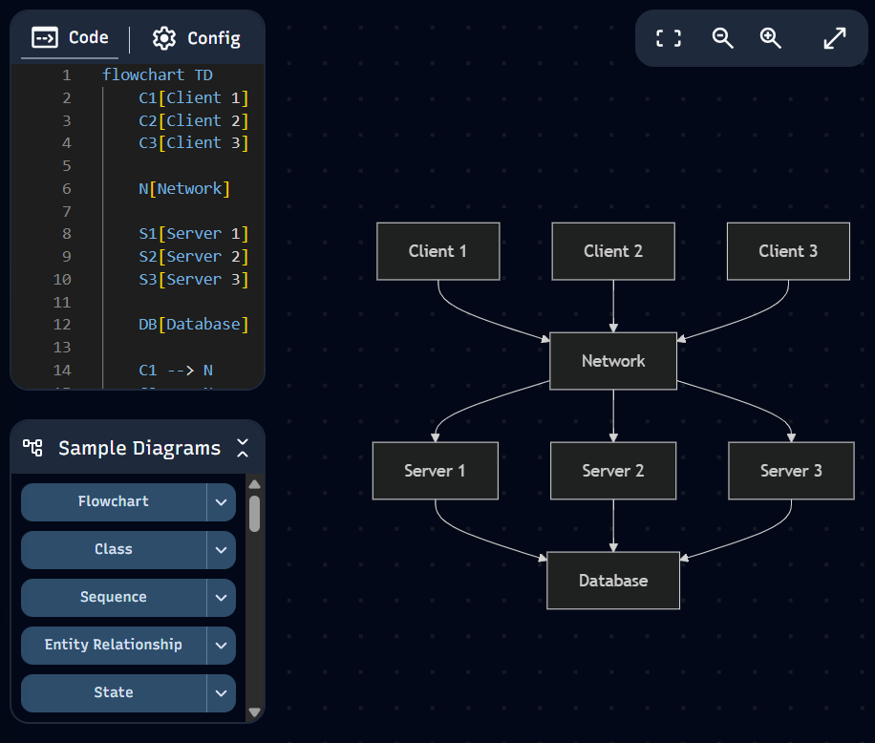
- Peer-to-Peer Architecture: Nodes can act as both clients and servers.
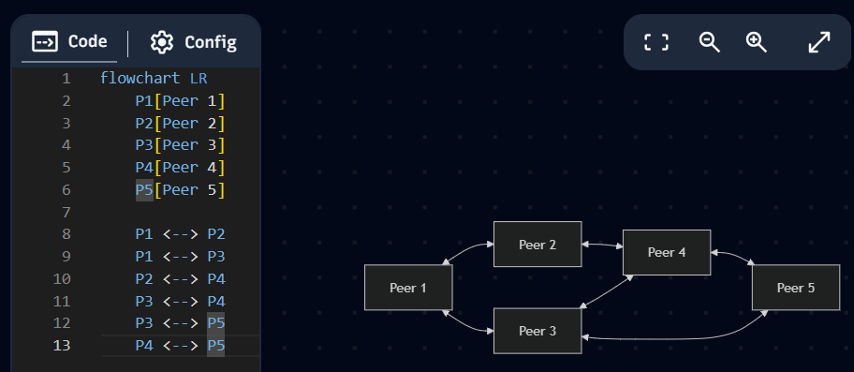
- Cluster Architecture: Multiple interconnected computers work together as a single computing environment.
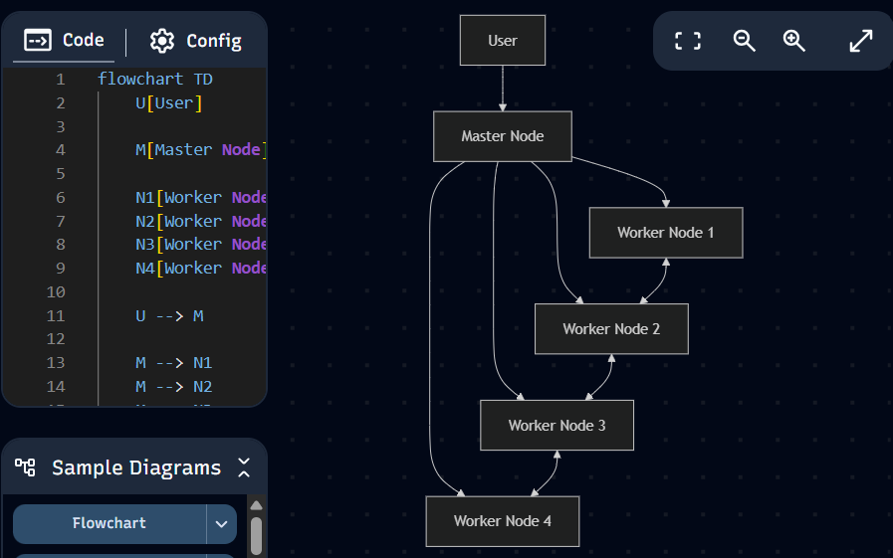
- Cloud-Based Architecture: Computing resources are provided through distributed cloud infrastructure.
- Edge Architecture: Processing is moved closer to the devices generating or consuming the data.

3. Key Components and Technologies
Important components and technologies used in distributed computing include:
3.1 Distributed Nodes
Nodes are individual computers, servers, virtual machines, or devices participating in the system.
3.2 Communication Networks
Networks allow nodes to exchange data and coordinate their activities. Communication can occur through wired or wireless networks.
3.3 Distributed Storage
Data can be stored across multiple machines instead of a single storage device. This improves capacity, availability, and fault tolerance.

3.4 Distributed Databases
Distributed databases store data across multiple locations while allowing applications to access it as part of a unified system.
3.5 Parallel Processing
Large computational tasks can be divided into smaller tasks that execute simultaneously on different processors or machines.
3.6 Cloud Computing
Cloud platforms provide distributed computing resources such as processing power, storage, databases, and networking on demand.
3.7 Big Data Technologies
Technologies such as Hadoop and Apache Spark allow organizations to process very large datasets across clusters of computers.
3.8 Containers and Orchestration
Containers package applications and their dependencies, while orchestration technologies such as Kubernetes help manage applications across multiple machines.

4. Applications / Real-World Use Cases
Distributed computing is widely used in modern applications.
Cloud Computing
Cloud providers use large numbers of distributed servers to provide computing, storage, databases, and other services to users.
Social Media
Social-media platforms process enormous amounts of posts, images, videos, messages, and user interactions using distributed infrastructure.
Online Banking
Banks use distributed systems for transaction processing, account management, authentication, and fraud detection.
E-Commerce
Online shopping platforms use distributed computing to manage product catalogs, customer requests, payments, inventory, and recommendations.
Artificial Intelligence and Machine Learning
Large AI models can be trained using multiple GPUs or computing nodes simultaneously. Distributed processing reduces the time required for large-scale training.
Healthcare
Hospitals and healthcare platforms can use distributed systems to manage patient information, medical images, remote monitoring, and data analytics.
Internet of Things
IoT systems generate data from large numbers of connected devices. Distributed and edge computing can process this data closer to where it is generated.
Scientific Research
Scientific simulations, weather forecasting, space research, and large-scale experiments require significant computational resources and can benefit from distributed processing.

5. Advantages and Limitations
Advantages
- Improved performance: Tasks can execute simultaneously across multiple nodes.
- Scalability: More nodes can be added when additional resources are required.
- Fault tolerance: The system can continue operating even when some nodes fail.
- Resource sharing: Computing resources can be shared efficiently.
- High availability: Services can remain accessible through redundant components.
- Geographical flexibility: Resources can be located in different geographical regions.
- Efficient large-data processing: Large datasets can be processed in parallel.
Limitations
- Complexity: Designing and maintaining distributed systems is more difficult than managing a single system.
- Network dependency: Communication failures can affect system performance.
- Synchronization problems: Nodes must coordinate their operations correctly.
- Security risks: Data travels between multiple systems and networks.
- Data consistency: Maintaining consistent copies of data across nodes can be challenging.
- Debugging difficulty: Identifying failures in a distributed environment can be complicated.
- Communication overhead: Nodes need to exchange information, which can introduce delays.

6. Recent Developments and Trends
Distributed computing continues to evolve with new technologies and computing requirements.
Edge Computing
Edge computing processes data closer to the source instead of sending all data to a centralized cloud. This reduces latency and network usage.
Serverless Computing
Serverless platforms allow developers to execute application functions without directly managing servers. The underlying infrastructure is distributed and automatically scaled.
Distributed Artificial Intelligence
AI workloads are increasingly distributed across multiple CPUs, GPUs, and specialized accelerators to train and deploy large models efficiently.
Cloud-Native Applications
Modern applications are increasingly designed as distributed services using containers, microservices, and orchestration platforms.
Distributed Ledger Technology
Blockchain and other distributed ledger technologies maintain records across multiple participating nodes without relying on a single central database.
Internet of Things
The increasing number of connected devices is creating a greater demand for distributed and edge processing.

7. Challenges and Future Scope
Distributed computing faces several technical challenges:
- Network failures and latency
- Data consistency and synchronization
- Security and privacy
- Fault detection and recovery
- Load balancing
- Resource management
- Scalability
- Distributed system monitoring
- Complexity of system design

Future Scope
The future of distributed computing is strongly connected with AI, edge computing, cloud computing, IoT, and autonomous systems. As applications generate larger datasets and require faster responses, computing resources will increasingly be distributed between centralized cloud data centers and edge devices.
AI-assisted resource management may also improve workload scheduling, fault prediction, and automatic scaling. Future distributed systems are expected to become more autonomous, scalable, energy-efficient, and capable of handling real-time applications.

8. Case Study / Example
Case Study: Apache Hadoop Distributed Computing
Apache Hadoop is an example of a distributed computing framework designed to process large datasets across clusters of computers.
In a Hadoop cluster, large datasets can be distributed across multiple machines. Instead of processing the entire dataset on one computer, the workload is divided among multiple nodes.
The Hadoop Distributed File System (HDFS) stores data across multiple machines and provides fault tolerance through data replication. Hadoop's MapReduce programming model allows computational work to be divided into smaller tasks that can be executed across the cluster.
For example, suppose an organization needs to analyze billions of customer transactions. Processing the complete dataset on one computer could take a very long time. Hadoop can distribute the data and computation across many machines, allowing different parts of the dataset to be processed in parallel.
This demonstrates the main idea of distributed computing: multiple independent computers cooperate to solve a large computational problem efficiently.

9. Conclusion and References
Conclusion
Distributed computing has become an important foundation of modern computing. It allows multiple computers and devices to cooperate, share resources, process large datasets, and provide reliable services. Its applications can be seen in cloud computing, artificial intelligence, big-data analytics, healthcare, banking, e-commerce, IoT, and scientific research.
Although distributed computing introduces challenges such as synchronization, security, network failures, and system complexity, its benefits make it essential for modern large-scale applications. With the continued development of cloud computing, edge computing, AI, and IoT, distributed computing will play an increasingly important role in the future of technology.
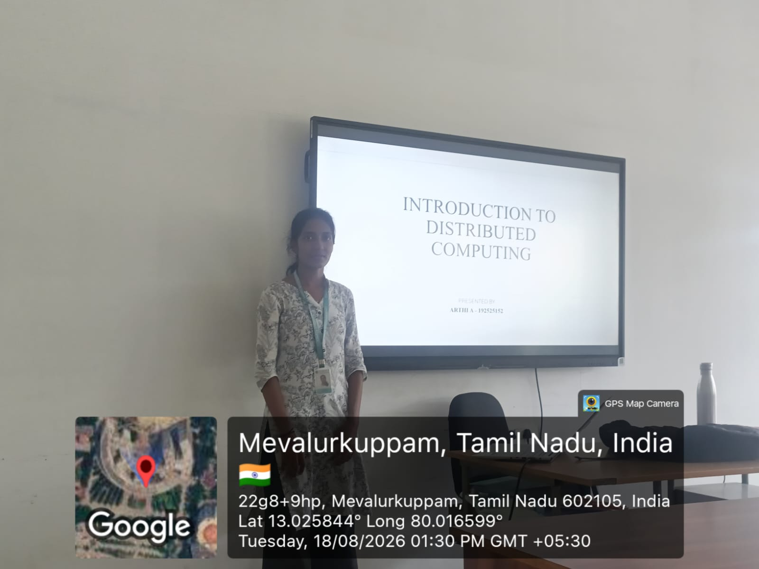

References
- Coulouris, G., Dollimore, J., Kindberg, T., & Blair, G. (2011). Distributed systems: Concepts and design (5th ed.). Addison-Wesley.
- Tanenbaum, A. S., & van Steen, M. (2007). Distributed systems: Principles and paradigms (2nd ed.). Pearson Prentice Hall.
- Dean, J., & Ghemawat, S. (2004). MapReduce: Simplified data processing on large clusters. Proceedings of the 6th Symposium on Operating System Design and Implementation (OSDI), 137–150.
- Ghemawat, S., Gobioff, H., & Leung, S.-T. (2003). The Google file system. Proceedings of the 19th ACM Symposium on Operating Systems Principles, 20–43.
- Dean, J., & Ghemawat, S. (2008). MapReduce: Simplified data processing on large clusters. Communications of the ACM, 51(1), 107–113.
- Tanenbaum, A. S., & van Steen, M. (2013). Distributed systems: Principles and paradigms (2nd ed.). Pearson Education.

Rubrics for Calculation
Evaluation Criteria | Excellent (4 Marks) | Good (3 Marks) | Satisfactory (2 Marks) | Needs Improvement (1 Mark)
Technical Content & Subject Knowledge (25%) | Comprehensive and accurate content; demonstrates excellent understanding of the emerging technology | Good technical understanding with minor gaps | Basic understanding with limited technical depth | Incomplete content or major technical errors
Organization & Presentation Structure (15%) | Excellent logical flow with clear introduction, content, conclusion, and effective transitions | Well-structured with minor organizational issues | Adequately structured but some sections lack clarity | Poorly structured and difficult to follow
Examples, Diagrams & Case Study (20%) | Excellent use of relevant diagrams, examples, applications, and real-world case studies | Good use of relevant examples and diagrams | Limited examples/diagrams with basic explanation | Inappropriate or insufficient examples/diagrams
Communication & Presentation Skills (20%) | Very clear, confident, engaging delivery with excellent eye contact, voice modulation, and time management | Clear and confident presentation with minor issues | Understandable but lacks confidence or engagement | Unclear delivery, excessive reading, or poor time management
Question Handling & Overall Performance (20%) | Answers questions accurately and confidently; demonstrates strong overall knowledge | Answers most questions correctly | Answers basic questions with some difficulty | Unable to answer questions or demonstrate adequate understanding

Criteria | Mark
Technical Content & Subject Knowledge (25%) | /5
Organization & Presentation Structure (15%) | /5
Examples, Diagrams & Case Study (20%) | /5
Communication & Presentation Skills (20%) | /5
Question Handling & Overall Performance (20%) | /5
TOTAL | /25

